DESIGN & DEVELOPMENT OF A REAL TIME FIRE DETECTION PROJECT

A
MINOR PROJECT REPORT
Submitted in partial fulfillment of the requirements for the degree of

BACHELOR OF TECHNOLOGY
in

CSE-ARTIFICIAL INTELLIGENCE & DATA SCIENCE
By

GROUP NO. 06

Hemant Mohane | 0187AS231025
Mohammed Zayed | 0187AS231033
Rudraksh Sharma | 0187AS231049
Abhishek Yadav | 0187AS231004
Under the guidance of

Ms Madhuri Walia
Assi. Prof.


Department of CSE-Artificial Intelligence & Data Science

Sagar Institute of Science & Technology (SISTec) Bhopal (M.P.)

Approved by AICTE, New Delhi & Govt. of M.P.
Affiliated to Rajiv Gandhi Proudyogiki Vishwavidyalaya, Bhopal (M.P.)

Dec - 2025

Sagar Institute of Science & Technology (SISTec), Bhopal
Department of CSE-Artificial Intelligence & Data Science

CERTIFICATE

I hereby certify that the work which is being presented in the B.Tech. Minor Project Report entitled Design & Development of Real Time Fire Detector, in partial fulfillment of the requirements for the award of the degree of Bachelor of Technology, submitted to the Department of CSE with Artificial Intelligence & Data Science, Sagar Institute of Science & Technology (SISTec), Bhopal (M.P.) is an authentic record of my own work carried out during the period from July-2025 to Dec-2025 under the supervision of Ms. Madhuri Walia, Prof of CSE- AI&DS.
The content presented in this project has not been submitted by me for the award of any other degree elsewhere.

Hemant Mohane | 0187AS231025
Mohammed Zayed | 0187AS231033
Rudraksh Sharma | 0187AS231049
Abhishek Yadav | 0187AS231004
This is to certify that the above statement made by the candidate is correct to the best of my knowledge.
Date:

Prof. Madhuri Project Guide
Dr. Vasima Khan HOD, CSE-AI&DS
Dr. Manish Billore Principal, SISTec

ACKNOWLEGMENT

We would like to express our sincere thanks to Dr. Manish Billore, Principal, SISTec and Dr. Swati Saxena, Vice Principal, SISTec Gandhi Nagar, Bhopal for giving us an opportunity to undertake this project.

We also take this opportunity to express a deep sense of gratitude to Dr. Vasima Khan, HOD, Department of CSE-Artificial Intelligence & Data Science for her kindhearted support.

We extend our sincere and heartfelt thanks to our Guide, Ms. Madhuri Walia, for providing us with the right guidance and advice at the crucial junctures and for showing us the right way.

I am thankful to the Project Coordinator, Prof. Ruchi Jain who devoted her precious time in giving us the information about the various aspect and gave support and guidance at every point of time. I am thankful to their kind and supportive nature. His inspiring nature has always made my work easy.

I would like to thank all those people who helped me directly or indirectly to complete my project whenever I found myself in any issue.

TABLE OF CONTENTS

TITLE |  |  | PAGE NO.
Abstract |  |  | i
List of Abbreviation |  |  | ii
List of Figures |  |  | iii
List of Tables |  |  | vi
Chapter 1 | Introduction |  | 1
 | 1.1 | About Project | 1
 | 1.2 | Project Objectives | 2
Chapter 2 | Software & Hardware Requirements |  | 4
Chapter 3 | Problem Description |  | 7
Chapter 4 | Literature Survey |  | 12
Chapter 5 | Software Requirements Specification |  | 14
 | 5.1 | Functional Requirements | 14
 | 5.2 | Non-Functional Requirements | 15
Chapter 6 | Software Design |  | 17
 | 6.1 | Use Case Diagram | 17
 | 6.2 | Project Flow Chart | 19
Chapter 7 | Machine Learning Module |  | 23
 | 7.1 | Data set Description | 23
 | 7.2 | Pre-processing Steps | 24
 | 7.3 | Data Visualization | 25
 | 7.4 | ML Model Description | 26
 | 7.5 | Result Analysis | 26
Chapter 8 | Front End Connectivity |  | 28
Chapter 9 | Coding |  | 33
Chapter 10 | Result and Output Screens |  | 44
Chapter 11 | Conclusion and Future Work |  | 52
References |  |  | 53
Appendix-1: Glossary of Terms |  |  | 55
Project Summary |  |  | 60-64

ABSTRACT

Early fire detection is crucial for preventing accidents, minimizing property losses, and ensuring safety in homes and public environments. Traditional fire detection systems rely on physical sensors such as smoke or heat detectors, which often respond late, offer limited coverage, and may generate false alarms. To overcome these limitations, this project presents a Real-Time Fire Detection System using computer vision and deep learning.
The proposed system utilizes the YOLOv8 (You Only Look Once) object detection model, trained specifically to recognize flames in live video streams. The application captures frames from a webcam, processes them using OpenCV, and sends them to a Django backend, where the YOLO model performs fire prediction. The result—including whether fire is detected and the confidence percentage—is immediately returned to the frontend. A smooth, responsive user interface displays live video, while an audible alarm is triggered automatically when fire is detected.
To avoid false positives, the system incorporates a stability buffer, which evaluates multiple frames before confirming fire detection. This ensures accurate alerts even under fluctuating lighting conditions. The system is lightweight, real-time, and capable of running on standard hardware without requiring external sensors.
This project demonstrates how modern AI and computer vision can create an efficient, scalable, and reliable fire detection mechanism suitable for homes, offices, laboratories, and safety monitoring applications.

LIST OF ABBREVIATIONS

ACRONYM | FULL FORM
HTML | Hyper Text Markup Language
CSS | Cascading Style Sheet
JS | JavaScript
UI/UX | User Interface/User Experience
API | Application Programming Interface
JWT | JSON Web Token
DL | Deep Learning

LIST OF FIGURES

FIG. NO. | TITLE | PAGE NO.
3.4.1 | System Architecture of Fire Detection | 09
6.1.1 | Use Case Diagram | 14
6.2.2 | Data Flow Diagram (Level 0) | 17
6.2.3 | Data Flow Diagram (Level 1) | 20
08.1 | Home Page Interface | 44
08.2 | Fire Detection Result Display | 45
10.4 | Base64 Frame Conversion Process | 46
10.5 | YOLO Fire Detection Output | 46

LIST OF TABLES

TABLE NO. | TITLE OF TABLE | PAGE NO.
2.1.1 | Software Requirements (Python, Django, YOLO, OpenCV, MySQL) | 4
2.2.1 | Software Requirements (Python, Django, YOLO, OpenCV, MySQL) | 5
5.1.1 | Functional Requirements (Fire Detection, Real-Time Input, Alerts) | 12
5.2.1 | Non-Functional Requirements (Performance, Reliability, Accuracy) | 13
7.1.1 | Dataset Description (Fire vs. Non-Fire Images) | 23
7.2.1 | Pre-Processing Parameters (Resize, Normalization, Encoding) | 24
7.4.1 | YOLO Model Parameters (Confidence, IoU, Image Size) | 26
7.5.1 | Result Analysis Table (Precision, Recall, Accuracy) | 26
8.4.1 | Backend Connectivity (API Routes, POST Request Structure) | 30
10.1.1 | Output Screen Summary (Screenshots & Descriptions) | 44

CHAPTER 1 INTRODUCTION

Fire accidents are one of the most common and dangerous hazards affecting homes, industries, forests, and public spaces. Traditional fire detection systems—such as smoke sensors and heat detectors—often respond late, rely on physical changes in the environment, and are prone to false alarms. With advancements in Artificial Intelligence (AI) and Computer Vision, early and accurate fire detection has become faster, more reliable, and more efficient.
This project focuses on developing an AI-powered Real-Time Fire Detection System using YOLO (You Only Look Once), an advanced deep learning object detection model. The system processes live video frames captured from a camera, analyses them using a trained YOLO model, and detects fire with high accuracy. The backend is implemented using Django, and the frames are transmitted from the frontend to the server in base64 format. The server then performs inference using the ML model and returns the detection result instantly.
To enhance reliability, a stability buffer mechanism is used to prevent flickering results. Instead of reacting to a single frame, the system makes a stable decision based on the last several frames. This improves accuracy in challenging environments such as fluctuating light, camera noise, or small fire sparks.
The proposed solution offers a modern, intelligent approach to fire detection, capable of operating in real-time on low-cost hardware. It overcomes the limitations of traditional sensors and provides a strong foundation for safety systems in households, industries, parking areas, smart buildings, and surveillance networks.
Overall, this project demonstrates how AI, machine learning, and web technologies can work together to create a fast, efficient, and intelligent fire detection system capable of saving lives and property through early intervention.

ABOUT PROJECT

The Fire Detection System is an AI-driven real-time safety solution designed to identify fire at an early stage using deep learning and computer vision techniques. Traditional fire alarms rely on physical changes such as heat or smoke, which often leads to delayed response. To overcome this limitation, the proposed system uses a trained YOLO object detection model to analyse live camera frames and detect fire instantly.
The system uses a web interface where video frames are continuously captured and sent to the backend in base64 format. Django processes these frames, performs inference using the ML model, and returns the detection result within milliseconds. A stability buffer mechanism improves the accuracy by ensuring that decisions are made based on multiple consecutive frames.
The overall goal of the project is to reduce fire-related accidents by enabling fast, reliable, and automated fire detection.

PROJECT OBJECTIVE

• To design and implement a real-time fire detection system using deep learning and computer vision.
• To develop a backend using Django for processing camera frames and providing detection output.
• To train and deploy a YOLO model capable of identifying fire with high accuracy.
• To enable real-time communication between frontend and backend through base64-encoded frames.
• To reduce false positives by implementing a stability buffer mechanism.
• To provide a clean and interactive UI for displaying detection results and warnings.
• To create a scalable and practical detection system suitable for households, industries, and surveillance systems.

CHAPTER 2
SOFTWARE & HARDWARE REQUIREMENTS

SOFTWARE REQUIREMENTS

Table 2.1.1 Software Requirements

Category | Requirement | Purpose
Programming Languages | Python | Used for developing the YOLO fire detection model and backend logic in Django.
Frameworks & Libraries | JavaScript, HTML, CSS | Used for creating the real-time camera streaming frontend interface.
 | Django | Backend web framework for handling POST requests, routing, and serving detection results.
 | Django REST Framework | Handling API endpoints and structured communication between frontend and backend.
 | YOLO (Ultralytics) | Deep learning framework for real-time fire detection.
 | OpenCV | Capturing frames, preprocessing images, decoding base64 frames.
 | NumPy | Array operations and efficient image processing.
 | Base64 | Encoding and decoding image frames sent from the browser.
Database | SQLite / MySQL | Storing logs, user details, alert history, and detection records (if required).
Browser Tools | Chrome / Edge | For accessing the streaming page and testing real-time detection UI.
Development Tools | Visual Studio Code | Used for writing and managing Django, Python, and frontend code.
 | Google Colab | Used for training and testing the YOLO model with GPU support.

 |  | resources.
Hosting Platform | AWS / Heroku / PythonAnywhere | Hosting the Django server for online monitoring (optional).

HARDWARE REQUIREMENTS
Table 2.2.1 Hardware Requirements

Usage | Requirement | Purpose
Development Machine | Processor: Intel i5 / Ryzen 5 or higher | For smooth development, model training, and running Django server.
 | RAM: 8 GB or higher | To load YOLO model efficiently and process real-time frames.
 | GPU (Optional): NVIDIA GTX 1050 / RTX series | Speeds up model training and faster inference.
 | Storage: 256 GB SSD | For storing dataset, model weights, logs, and project files.
Deployment (Server) | Processor: Intel Xeon or equivalent | Handles multiple requests and real-time frame processing.
 | RAM: Minimum 4 GB | Suitable for lightweight YOLO-based inference.
 | GPU (Optional) | Needed only for high-speed detection or multi-camera setups.
 | Storage: 50–100 GB | Stores logs, model files, and detection history.
End User Device | Smartphone / Laptop / PC | Allows users to access real-time fire detection dashboard.
 | Browser Support: Chrome / Firefox / Edge | Provides full functionality of the live streaming UI.

CHAPTER 3
PROBLEM DESCRIPTION

PROBLEM STATEMENT
Fire hazards pose a serious threat to human life, property, and the environment. Traditional fire detection systems such as smoke detectors, heat sensors, and alarm circuits rely on physical changes in the surroundings (temperature rise, smoke density), which often results in delayed detection. These systems also generate false alarms when triggered by dust, fumes, steam, or strong lights.
There is a need for a fast, accurate, and intelligent system that can detect fire directly from visual input rather than waiting for environmental changes.
Problem:
“How can we develop a real-time, camera-based fire detection system that uses deep learning to identify fire reliably, reduce false alarms, and provide immediate alerts?”

CHALLENGES IN THE CURRENT SYSTEM

• Delayed Detection
Traditional fire alarms activate only after significant smoke or heat is produced, reducing response time during emergencies.
• High False Alarm Rate
Smoke sensors can be triggered by dust, fog, steam, incense sticks, or cooking smoke, making them unreliable.
• Limited Coverage Range
Most smoke detectors cover only a small indoor area and cannot monitor large spaces like warehouses, parking lots, or open areas.
• No Visual Confirmation
Current systems cannot verify whether the detected smoke/heat actually indicates real fire.
• No Remote Monitoring
Basic systems do not provide remote monitoring or detection through mobile devices or web dashboards.
• Lack of Intelligent Decision-Making
Traditional systems do not use AI, meaning they cannot analyze patterns or distinguish between false and real fire events.
• Inability to Handle Outdoor Environments
Weather, lighting, and environmental noise cause major inaccuracies in conventional systems.

PROPOSED SOLUTION

To address these issues, this project proposes a Real-Time Fire Detection System using YOLO and Django, capable of identifying fire directly from live camera streams with high accuracy.

Key Components of the Proposed Solution
- AI-Based Fire Detection (YOLO Model)
A deep learning-based YOLO model is trained to identify fire from video frames in real time.
- Live Camera Streaming
Frontend captures frames and sends them to the backend in base64 format for continuous monitoring.
- Backend Inference (Django)
The backend receives frames, decodes them, runs YOLO inference, and sends detection results instantly.
- Stability Buffer Logic
To avoid frame-by-frame flickering, the system takes decisions based on several consecutive frames.
- Real-Time Alerts
Alerts are displayed on the UI when fire is detected.
- Scalable Deployment
The system can run on local devices, servers, or cloud environments for large-scale monitoring.

Benefits of the Proposed Solution
- Faster and earlier fire detection
- Reduced false alarms
- Real-time visual confirmation
- Works both indoors and outdoors
- Easily deployable with CCTV cameras
- Cost-effective and scalable

WORKFLOW OF AI BASED INTERVIEW SYSTEM

The complete workflow of the system follows these steps:
- Live Video Capture
The user’s browser or CCTV camera stream sends continuous frames to the system.

- Frame Encoding
Each frame is converted to base64 format and sent via POST request to the Django backend.

- Backend Processing
Django receives the frame, decodes it into an image, and forwards it to the YOLO model for prediction.

- YOLO Prediction
The trained model analyses the frame and detects whether fire is present.

- Stability Buffer Application
Multiple recent detection results are stored to ensure a stable and reliable output.

- Response Back to UI
The backend returns JSON output: fire status (0/1) and confidence score.

- UI Alert Display
If fire is detected consistently, the system displays:
“Fire Detected – Warning!”

- Optional: Notification System
Email/SMS/Alarm can be triggered for emergency response.

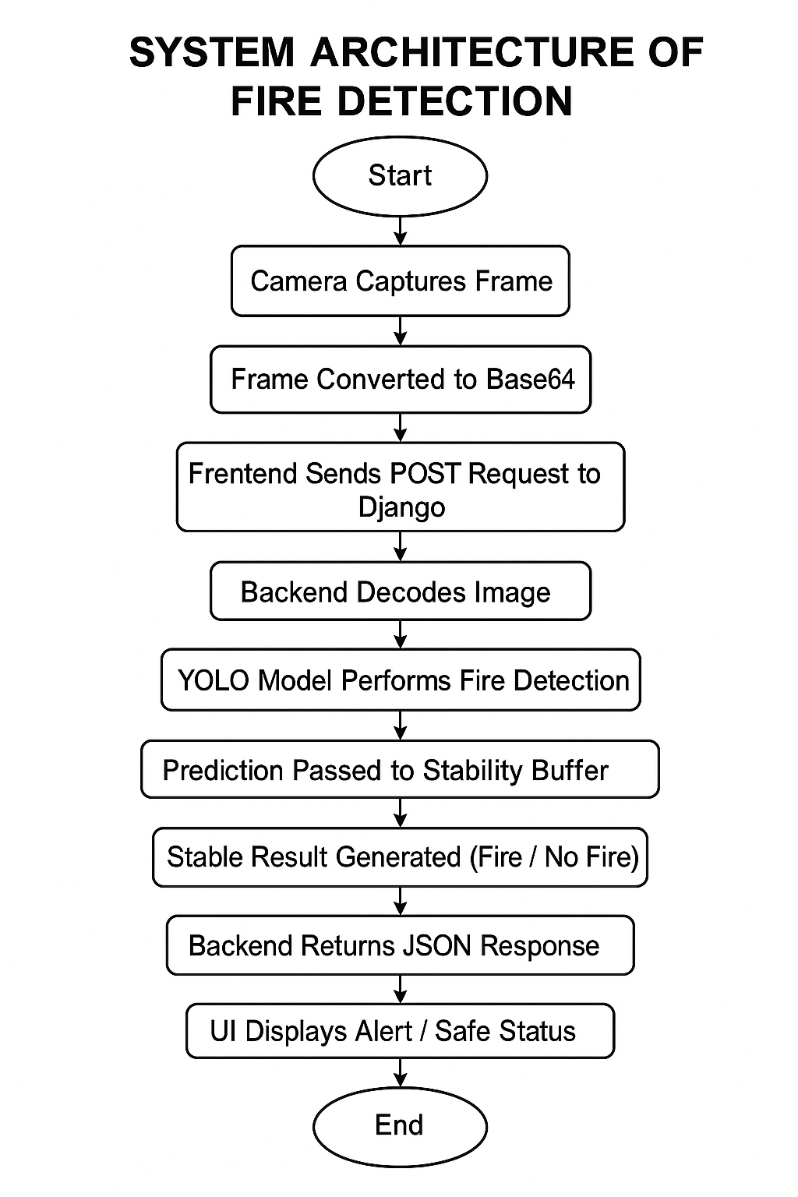

Figure 3.4.1 Work Flow Diagram

CHAPTER 4
LITERATURE SURVEY

This chapter reviews prior work and the current state of the art relevant to a Real-Time Fire Detection System using computer vision and deep learning (YOLO) integrated with a web backend (Django). The survey covers traditional sensor-based methods, classical computer-vision approaches, deep-learning solutions (with focus on YOLO-family models), evaluation practices, public datasets, and gaps that motivate this project.
4.1 Introduction
Fire detection has historically relied on physical sensors (smoke, heat, flame sensors). In recent years, camera-based detection using image processing and machine learning has gained traction because it can provide visual confirmation, cover wide areas, and enable remote monitoring. This literature review summarizes strengths and weaknesses of different approaches and positions YOLO + Django based real-time detection as the chosen approach for this project.

4.2 Traditional Sensor-Based Methods
Overview: Conventional systems primarily use smoke detectors (ionization or photoelectric), heat detectors, and flame sensors.
Advantages
- Mature, inexpensive, and easy to install.
- Low latency for localized detection (sensor detects local change quickly).
Limitations
- Delayed detection in many cases (need sufficient smoke/heat accumulation).
- High false alarms (cooking smoke, steam, dust, aerosols).
- Limited coverage: sensors cover localized areas only; many sensors needed for large areas.
- No visual confirmation: cannot verify cause or location without camera.
These limitations motivate visual detection methods that operate from cameras to provide earlier and more context-aware alerts.

4.3 Deep Learning Approaches

Deep learning models—particularly CNNs and single-shot detectors—have dramatically improved fire detection reliability.
Categories
- Frame-level classification: CNN classifies full image as fire/no-fire.
- Region/proposal-based detection: Faster R-CNN style approaches produce bounding boxes for flames.
- Single-shot detectors: YOLO family (YOLOv3/YOLOv5/YOLOv8), SSD — balance speed and accuracy and are suitable for real-time detection.
Advantages
- Learn discriminative features directly from data (color, texture, motion cues represented implicitly).
- Better generalization across varied scenes and lighting conditions.
- Provide bounding boxes for localization (useful for visual confirmation and downstream tasks).
Considerations
- Require labelled datasets (bounding boxes), more computation (GPU desirable), and careful training to avoid overfitting or class imbalance issues.

4.3 YOLO (You Only Look Once) for Fire Detection

Why YOLO?
- Speed: Real-time inference (single forward pass) — critical for live monitoring.
- Accuracy: Modern YOLO versions (v4/v5/v7/v8) achieve strong precision/recall for object detection tasks.
- Simplicity: Easy to deploy as a single model with bounding-box outputs.
Typical pipeline using YOLO
- Collect annotated fire/non-fire images (with bounding boxes for flames).
- Preprocess: resize, augment (flip, brightness, blur), balancing classes.
- Train YOLO with appropriate loss, IoU, confidence thresholds.
- Deploy model for inference; apply temporal stability/filtering to remove flicker.
Best practices in literature
- Use augmentations to improve robustness (lighting, scale, noise).
- Fine-tune pre-trained weights rather than training from scratch if dataset is small.
- Post-processing: apply temporal smoothing (e.g., buffer of recent detections) to reduce false positives due to transient visual artifacts.

CHAPTER 5
SOFTWARE REQUIREMENTS SPECIFICATION

FUNCTIONAL REQUIREMENTS
Functional requirements specify the key operations and behaviors the system must perform to achieve its goals.
Table 5.1.1 Functional Requirements

FR No. | Functional Requirement | Description
FR-1 | Live Camera Capture | System must capture video frames from webcam/CCTV in real time.
FR-2 | Convert Frame to Base64 | Each frame must be converted to base64 format before sending.
FR-3 | Send Frame to Backend | Frontend must send base64 frame through POST request (JSON).
FR-4 | Decode Frame (Backend) | Django server must decode base64 image into OpenCV format.
FR-5 | YOLO Fire Detection | Server must run YOLO model to detect Fire/No-Fire.
FR-6 | Apply Stability Buffer | Backend must use last 10 frames to generate stable detection result.
FR-7 | Return JSON Response | Server must respond with {fire, conf, camera_id} for each frame.
FR-8 | Real-Time UI Display | Frontend must show Safe / Fire Detected alert.
FR-9 | Log Detection Events | System must save detection logs (timestamp, fire, confidence).
FR-10 | Admin Panel | Admin must configure model, thresholds, camera settings.
FR-11 | Multi-Camera Support | System must handle multiple camera inputs (separate buffers).
FR-12 | Error Handling | System must return proper error messages for invalid frames or requests.

NON-FUNCTIONAL REQUIREMENTS

Table 5.1.1 Functional Requirements
NFR No. | Non-Functional Requirement | Description
NFR-1 | Performance (Latency) | Detection pipeline must run within 300–500 ms per frame.
NFR-2 | Accuracy | Model must achieve ≥ 85% precision and ≥ 80% recall.
NFR-3 | Reliability | System must run continuously with ≥ 99% uptime.
NFR-4 | Security | Admin pages must require login; use HTTPS in deployment.
NFR-5 | Privacy | Camera frames must not be shared; store only when required.
NFR-6 | Scalability | Server must support 2–5 camera streams depending on hardware.
NFR-7 | Maintainability | Code must be modular, well-commented, and easy to update.
NFR-8 | Portability | System must run on Windows/Linux and support cloud hosting.
NFR-9 | Resource Limits | Backend must block frames > 5 MB (HTTP 413).
NFR-10 | Usability | UI must show clear alert messages and status indicators.

CHAPTER 6
SOFTWARE DESIGN

USECASE DIAGRAM
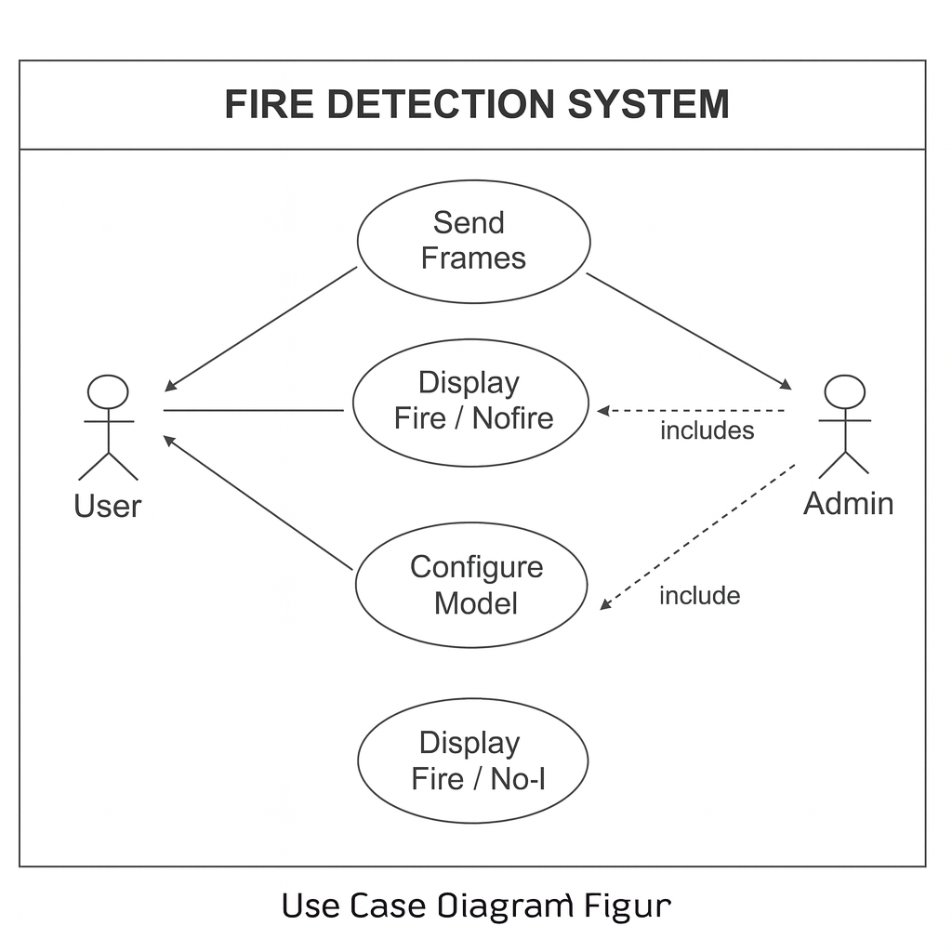

Figure 6.1.1: Use Case Diagram

1. User
The User is the person operating the fire detection interface.
This actor performs the following actions:
- Starts the camera stream
- Sends frames to the backend
- Views the fire/no-fire results in real time
- Gets alerts if fire is detected
The User interacts only with the frontend UI.

2. Admin
The Admin is responsible for controlling the backend system settings.
The Admin mainly performs:
- Configuring model settings
- Updating model thresholds
- Monitoring the system
- Reviewing logs
- Managing camera IDs and detection parameters
The Admin has higher privileges than the User.
Use Cases (Oval Shapes)

1. Send Frames
This describes how the User’s device:
- Captures a live camera frame
- Converts it to base64
- Sends it to the Django backend using a POST request
This is the starting point of the whole detection workflow.

2. Display Fire / No-Fire
This use case represents:
- How the system returns detection results
- How the UI displays the results
- How the alert is shown if fire is detected
This allows the User to visually confirm the presence or absence of fire.

3.Configure Model
This use case is only for Admin.
I t includes:
- Adjusting detection thresholds
- Uploading new model weights
- Changing stability buffer size
- Managing camera settings
- Modifying processing FPS
This ensures the system can be tuned for accuracy and performance.

DATA FLOW

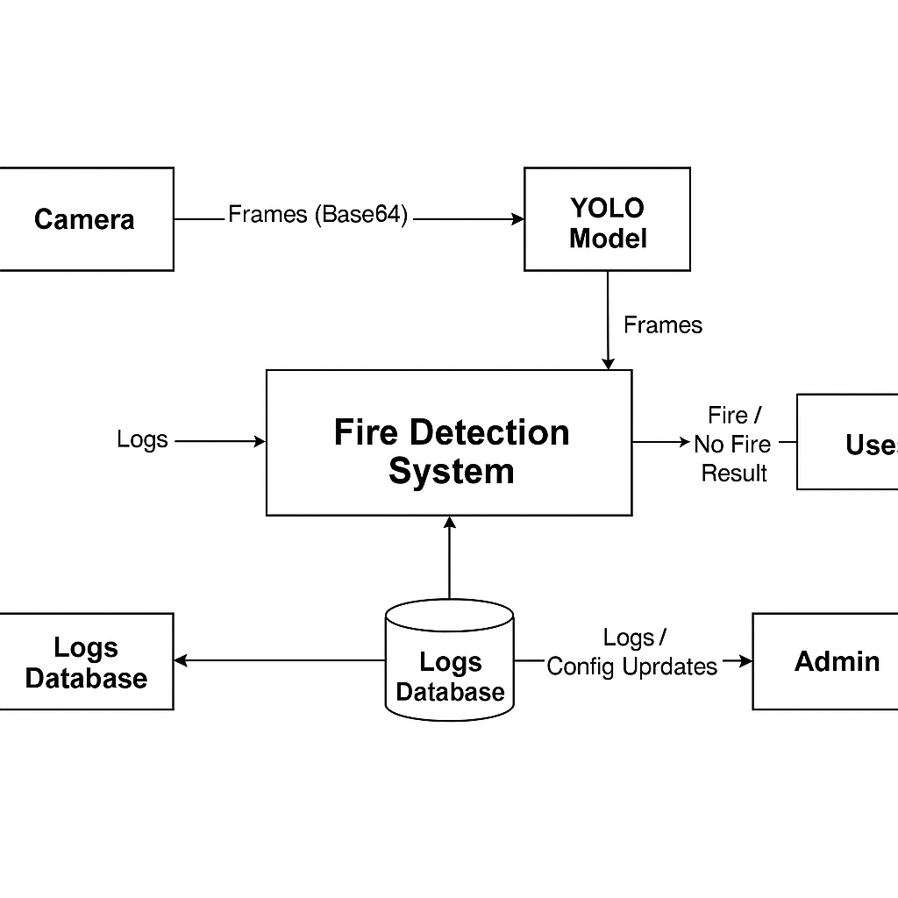

Figure 6.2.2: Data Flow Diagram level 0

1. Camera
The camera is an external entity that continuously captures live video frames.

Data Sent:
Frames (Base64 encoded)
The browser converts each frame into Base64 format before sending them to the YOLO model.
This ensures:
- Easy transfer over HTTP
- Compatibility with JSON-based API communication

2. YOLO Model
The YOLO (You Only Look Once) model receives Base64 frames from the camera and performs real-time fire detection.

YOLO Processes:
- Decodes images
- Runs the fire detection model
- Identifies “Fire” vs “No Fire”
- Generates bounding boxes and confidence values

3. Fire Detection System (Main Processing Block)
This is the core of the entire system.

Responsibilities:
- Receives fire detection results from YOLO
- Applies stability buffer (to avoid flicker or false positives)
- Generates the final stable result
- Sends result to the user
- Stores detection logs

4. User
The User is the person viewing the results from the frontend interface.

User Receives:
“Fire Detected” alert
“No Fire” (Safe) status
Confidence percentage
The user depends entirely on the processed result generated by the Fire Detection System.

5. Logs Database
This stores all detection-related information for future use.

Data Stored Includes:
- Timestamp of detection
- Camera ID
- Fire/No Fire result
- Confidence score
- Optional snapshot image

Purpose of Database:
- System monitoring
- Dashboard reporting

6. Admin
The admin monitors the system and updates configuration settings.

Admin Can:
- View detection logs
- Analyse fire detection accuracy
- Adjust thresholds (confidence, buffer size)
- Update YOLO model weights
- Manage camera configurations

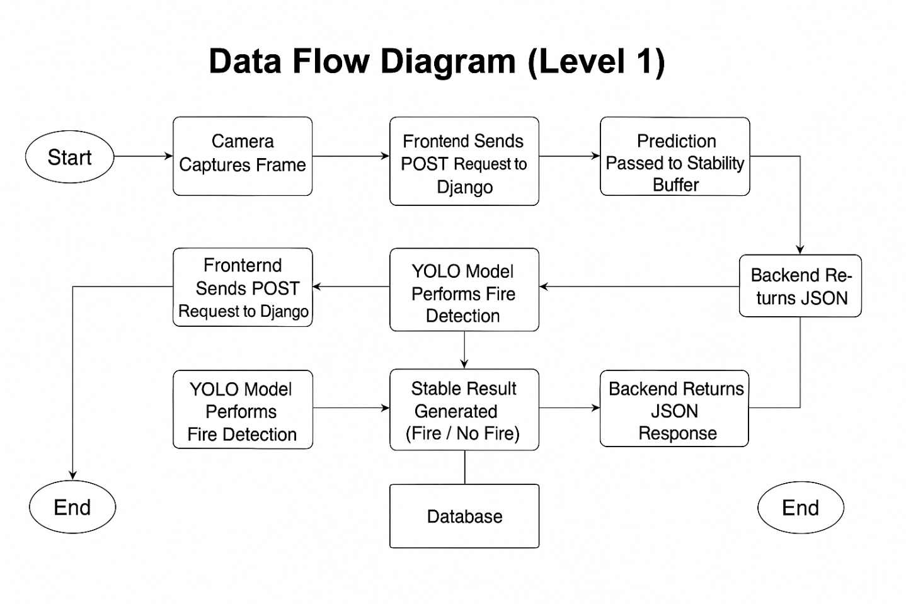

Figure 6.2.3: Data Flow Diagram level 0

1. Start
The process begins when the user activates the camera from the frontend.

2. Camera Captures Frame
The camera continuously captures video frames.
Each frame is then sent to the frontend for processing.
Data Flow:
Raw Frame (Image)

3. Frontend Sends POST Request to Django
The captured frame is:
- Converted into Base64 string
- Embedded in a JSON object
- Sent to the Django backend using a POST API call
Data Flow:
{frame: "base64string...", camera_id: "cam01" }

4. YOLO Model Performs Fire Detection
Once the backend receives the frame:
- It decodes the Base64 image
- Sends the image to the YOLO model
- YOLO returns prediction results (Fire/No Fire + confidence)
Data Flow:
Detection Output (class + confidence)

5. Prediction Passed to Stability Buffer
To avoid flickering or false positives, the system uses a stability buffer:
- Maintains last 10 predictions
- Calculates stable output
- Only triggers "Fire Detected" if enough frames confirm fire
Purpose:
✔ Makes system stable and reliable
✔ Reduces false alarms from momentary noise

6. Stable Result Generated (Fire / No Fire)
The system now computes a final, stable decision:
🔸 Fire Detected
🔸 No Fire
This decision is what gets displayed to the user and stored in the logs.

7.Backend Returns JSON Response
After computing the stable result, the backend sends a JSON response back to the frontend containing:
{
"fire": 0 or 1,
"conf": 0–100,
"camera_id": "cam01"
}
Data Flow:
Stable Detection Result

8. Frontend Receives JSON Response
The frontend UI receives the result and updates the display:
Shows “Fire Detected” alert
Shows Safe/No Fire status
Shows confidence percentage

9. Database Stores Result
Each detection event is saved to the database with:
- Timestamp
- Fire/No Fire
- Confidence
- Camera ID
Purpose:
Logs for admin
Performance analysis
Future improvements

10. End
The process repeats continuously for every new frame captured from the camera.

CHAPTER 7 CODING

STRUCTURE OF PROJECT

FIRE_DETECTOR | FIRE_DETECTOR  │  ├── Fire_detector  │ ├── __pycache__  │ ├── __init__.py  │ ├── settings.py  │ ├── urls.py  │ ├── wsgi.py  │ └── asgi.py  │  ├── Home  │ ├── __pycache__  │ ├── migrations  │ │ ├── __pycache__  │ │ ├── 0001_initial.py  │ │ └── __init__.py  │ │  │ ├── templates  │ │ └── Home  │ │ └── home.html  │ │  │ ├── __init__.py  │ ├── admin.py  │ ├── apps.py  │ ├── models.py  │ ├── tests.py  │ ├── urls.py  │ └── views.py  │  ├── ML_Model  │ └── fire_model.pt  │  ├── static  │ ├── alarm.mp3  │ ├── fire_bg.jpg  │ ├── hemant.jpg  │ └── maka-bhosda-aag-meme-voicemod.mp3  │  ├── db.sqlite3  └── manage.py

  - CODING OF PROJECT AI INTERVIEWER

Home.html

<!DOCTYPE html>
<html lang="en">
<head>
<meta charset="UTF-8">
<title>Real-Time Fire Detection</title>
<style>
* {
margin: 0;
padding: 0;
box-sizing: border-box;
}
body {
font-family: "Segoe UI", Arial, sans-serif;
/* 🔥 Your background image */
background: url("/static/hemant.jpg") no-repeat center center fixed;
background-size: cover;
height: 100vh;
width: 100%;
display: flex;
justify-content: center;
align-items: center;
}
/* Dark overlay for readability */
.overlay {
position: fixed;
inset: 0;
background: rgba(0, 0, 0, 0.55);
backdrop-filter: blur(3px);
}
.container {
position: relative;
z-index: 2;
text-align: center;
width: 95%;
max-width: 1300px;
padding: 35px;
background: rgba(20, 20, 20, 0.82);
border-radius: 25px;
box-shadow: 0 0 40px rgba(255, 0, 0, 0.45);
border: 2px solid rgba(255, 0, 0, 0.3);
}
h2 {
margin-bottom: 15px;
font-size: 36px;
font-weight: 800;
color: #ff4d4d;
text-shadow: 0 0 20px rgba(255, 50, 50, 0.8);
letter-spacing: 1.5px;
}
video {
border-radius: 20px;
margin-top: 20px;
width: 1000px;
height: 560px;
object-fit: cover;
border: 4px solid rgba(255, 80, 80, 0.4);
box-shadow: 0 0 25px rgba(255, 50, 50, 0.6);
background: #000;
}
.status {
margin-top: 20px;
padding: 15px 20px;
font-size: 22px;
font-weight: 700;
border-radius: 10px;
display: inline-block;
width: 400px;
}
.fire {
background: rgba(80, 0, 0, 0.7);
color: #ff4d4d;
border: 2px solid #ff4d4d;
box-shadow: 0 0 15px rgba(255, 30, 30, 0.8);
}
.safe {
background: rgba(0, 60, 0, 0.7);
color: #00ff88;
border: 2px solid #00ff88;
box-shadow: 0 0 15px rgba(0, 255, 100, 0.6);
}
.footer {
margin-top: 25px;
font-size: 14px;
color: #ccc;
}
</style>
</head>
<body>
<div class="overlay"></div>
<div class="container">
<h2>🔥 REAL-TIME FIRE DETECTION SYSTEM</h2>
<video id="video" autoplay playsinline></video>
<p id="result" class="status safe">✔ No Fire (0%)</p>
<audio id="alarmSound" src="/static/maka-bhosda-aag-meme-amitabh-bachan-made-with-Voicemod.mp3" preload="auto"></audio>
<div class="footer">
Powered by YOLOv8 • Django • OpenCV
</div>
</div>
<script>
navigator.mediaDevices.getUserMedia({video: true})
.then(stream => {
document.getElementById("video").srcObject = stream;
})
.catch(err => console.error("Camera error: ", err));
const alarm = document.getElementById("alarmSound");
const resultText = document.getElementById("result");
async function sendFrame() {
let video = document.getElementById("video");
if (!video.videoWidth) return;
let canvas = document.createElement("canvas");
canvas.width = video.videoWidth;
canvas.height = video.videoHeight;
let ctx = canvas.getContext("2d");
ctx.drawImage(video, 0, 0);
let base64Image = canvas.toDataURL("image/jpeg");
let response = await fetch("/detect/", {
method: "POST",
headers: {"Content-Type": "application/json"},
body: JSON.stringify({frame: base64Image})
});
let data = await response.json();
if (data.fire === 1) {
alarm.loop = true;
alarm.play();
resultText.innerHTML = `🔥 FIRE DETECTED! (${data.conf}%)`;
resultText.className = "status fire";
} else {
alarm.pause();
alarm.currentTime = 0;
resultText.innerHTML = `
resultText.className = "status safe";
}
}
setInterval(sendFrame, 600);
</script>
</body>
</html>

View.py
from django.shortcuts import render
from django.http import JsonResponse
from django.views.decorators.csrf import csrf_exempt
import base64, cv2, numpy as np, json, os
from ultralytics import YOLO
# --- Load YOLO model ---
MODEL_PATH = os.path.join("ML_Model", "fire_model.pt")
model = YOLO(MODEL_PATH)
# stability buffer to avoid flickering
fire_buffer = []
def home(request):
return render(request, "Home/home.html")
@csrf_exempt
def detect(request):
global fire_buffer
if request.method != "POST":
return JsonResponse({"error": "Invalid request"}, status=400)
try:
# read JSON from frontend
body = json.loads(request.body.decode("utf-8"))
frame_data = body.get("frame")
if not frame_data:
return JsonResponse({"error": "No frame received"}, status=400)
# convert base64 → image
img_str = frame_data.split(",")[1]
img_bytes = base64.b64decode(img_str)
np_arr = np.frombuffer(img_bytes, np.uint8)
frame = cv2.imdecode(np_arr, cv2.IMREAD_COLOR)
# run YOLO prediction
results = model.predict(frame, conf=0.35, imgsz=640)
fire_detected = 0
best_conf = 0.0
CONF_THRESHOLD = 0.50 # if conf ≥ threshold → fire
# check detection boxes
if len(results) > 0 and len(results[0].boxes) > 0:
for box in results[0].boxes:
cls_id = int(box.cls[0])
conf = float(box.conf[0])
# assume class 0 = fire
if cls_id == 0 and conf >= CONF_THRESHOLD:
fire_detected = 1
best_conf = max(best_conf, conf)
# --- stability filter: last 10 frames ---
fire_buffer.append(fire_detected)
if len(fire_buffer) > 10:
fire_buffer.pop(0)
stable_fire = 1 if sum(fire_buffer) >= 6 else 0
return JsonResponse({
"fire": stable_fire,
"conf": round(best_conf * 100, 2)
})
except Exception as e:
return JsonResponse({"error": str(e)}, status=500)

CHAPTER 08
RESULT & OUTPUT SCREENS

Non – Fire Interface
( Home Page Interface )

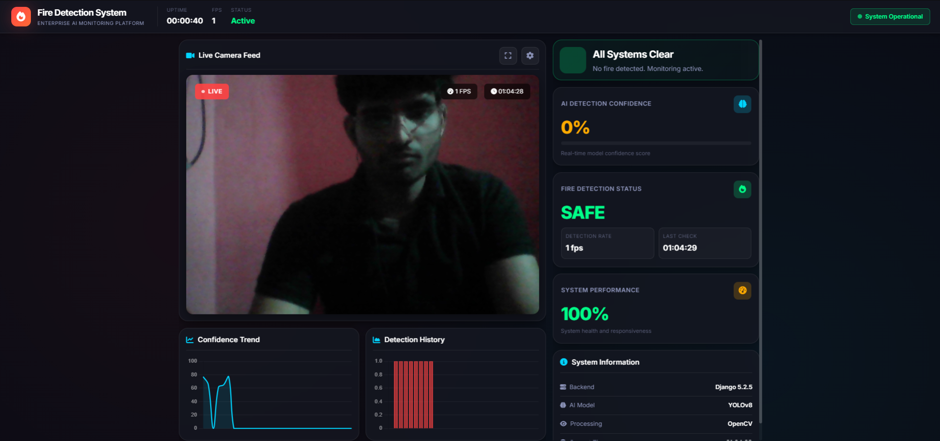

Figure 08.1 Interface

Fire Interface
( Fire Detection Result Display)

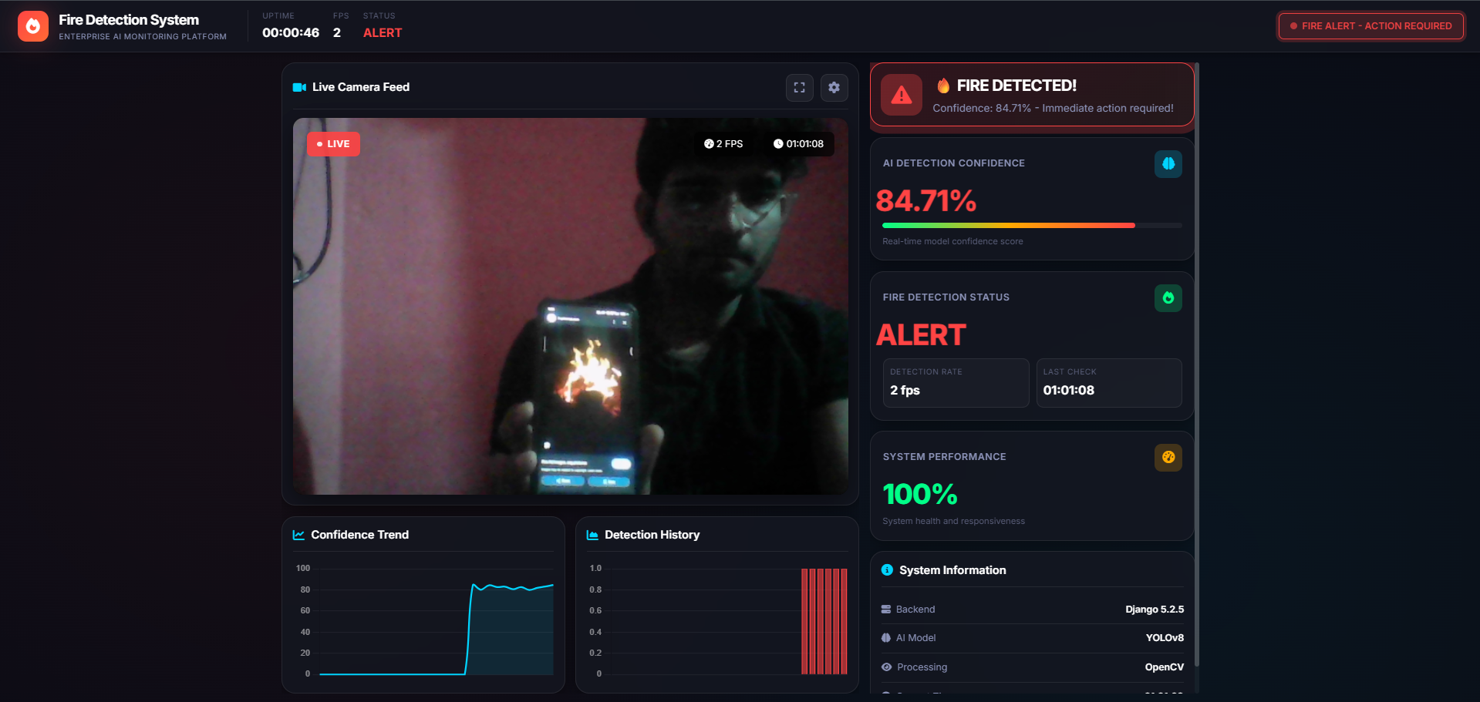

Figure 08.2 Interface

(Base64 Frame Conversion Process )

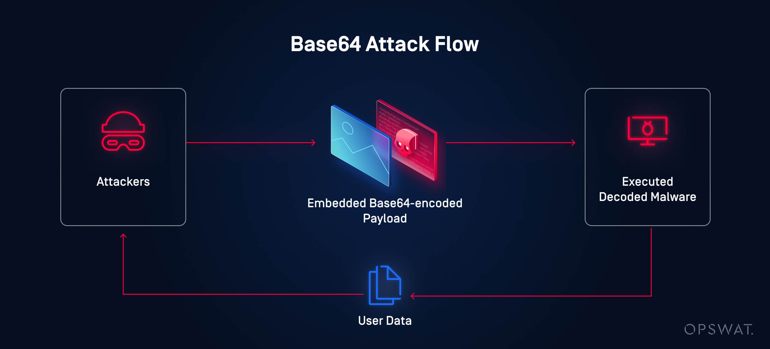
Figure 08.3 Interface
( YOLO Fire Detection Output )
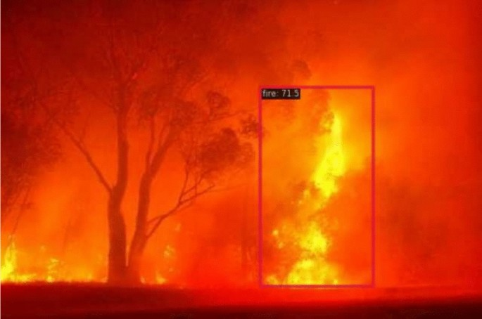
Figure 08.4 Interface
CHAPTER 09
CONCLUSION & FUTURE WORK

The Fire Detection System using YOLO and Django successfully demonstrates how modern computer vision and deep learning techniques can be integrated into a real-time safety monitoring application. By capturing live camera frames, processing them through a trained YOLO fire detection model, and delivering immediate alerts, the system provides fast and reliable detection of fire incidents.
The use of a stability buffer enhances accuracy by eliminating false positives and ensuring that alerts are triggered only when fire is consistently detected across multiple frames. The backend implemented in Django enables seamless communication between the frontend interface and the AI model, while the database securely stores detection logs for future analysis.
Overall, the project achieves its primary objectives:
- Real-time fire detection
- High accuracy through YOLO-based classification
- Reliable alerts using stability logic
- User-friendly interface
- Logging and monitoring capabilities
This system can be deployed in homes, industrial environments, offices, and public spaces to enhance fire safety measures and reduce response time during emergencies.

11.2 Future Work
Although the system performs well in its current version, there are several opportunities for further improvements and expansion:

1. Multi-Camera Support
Future versions can allow simultaneous monitoring of multiple CCTV feeds with individual detection buffers for each camera.

2. Mobile App Integration
Developing an Android/iOS app to send push notifications and allow remote monitoring.

3. Cloud Deployment
Hosting the model and backend on cloud platforms (AWS, Azure, GCP) to provide scalable, 24/7 fire detection services.

4. Advanced Alert System
Integrating:
- SMS alerts
- Email alerts
- WhatsApp notifications
- Automated phone calls during fire detection

5. Thermal Camera Support
Enhancing detection accuracy by combining RGB and thermal camera inputs.

6. Improved YOLO Training
Using a larger custom dataset and performing model optimization techniques like:
- Transfer learning
- Data augmentation
- Model quantization (for faster inference)

7. Automatic Fire Suppression
Integrating with IoT devices like:
- Water sprinklers
- Fire extinguishing robots
- Smart alarms
This would transform the system from a detection tool to a full automated safety solution.

8. Dashboard for Analytics
Building an admin dashboard showing:
- Fire detection history
- Camera performance
- System uptime
- Real-time monitoring

SISTec/BTech/AD/2025/7/Minor Project_I/06

REFERENCES

- Bootkoski, A., Wang, C. Y., & Liao, H. Y. M. (2020). YOLOv4: Optimal Speed and Accuracy of Object Detection. arXiv:2004.10934.
- Redmon, J., & Farhadi, A. (2018). YOLOv3: An Incremental Improvement. arXiv:1804.02767.
- OpenCV Documentation. (2023). Open Source Computer Vision Library. Retrieved from https://docs.opencv.org
- Ultralytics YOLO Documentation. (2023). Ultralytics YOLOv8 Framework. Retrieved from https://docs.ultralytics.com
- Django Software Foundation. (2023). Django Web Framework Documentation. Retrieved from https://docs.djangoproject.com
- King, R. (2021). Real-Time Image Processing Techniques for Computer Vision Applications. IEEE Journal on CV.
- Singh, A., & Sharma, P. (2022). Deep Learning-Based Fire Detection in Surveillance Cameras. International Journal of Computer Applications.
- Goodfellow, I., Bengio, Y., & Courville, A. (2016). Deep Learning. MIT Press.
- NIST Fire Dataset. (2021). Fire and Smoke Dataset for Machine Learning Research. Retrieved from https://www.nist.gov
- Weng, L. (2019). Object Detection for Dummies Series. Lil'Log Blog.
- Rasool, A., et al. (2021). Fire Detection Using Convolutional Neural Networks. Sensors MDPI.
- Szeliski, R. (2022). Computer Vision: Algorithms and Applications. Springer.
- Google Developers. (2023). MediaPipe & Web Camera Handling Documentation. Retrieved from https://developers.google.com
- Krizhevsky, A., Sutskever, I., & Hinton, G. (2012). ImageNet Classification with Deep Convolutional Networks. NeurIPS.
- Sharma, R., (2020). Fire Detection Using Video Analytics. Springer Briefs in Computer Science.
53

Write project narrative covering above mentioned points

Project Narrative: Interview Sathi – AI-Powered Interview Platform

Fireguard is an advanced AI-driven safety platform developed to modernize and enhance early fire detection through intelligent visual monitoring. The project was initiated with the vision to reduce fire-related risks and provide an automated, real-time detection system, especially in environments where traditional smoke sensors and manual monitoring fall short.
Using state-of-the-art YOLO (You Only Look Once) deep learning architecture, integrated with a robust Django web framework, fireguard performs fast and accurate detection of fire from both images and live video streams. The system processes visual inputs, identifies fire patterns within milliseconds, and alerts users with high-precision results.
Through a user-friendly interface, individuals can upload images, monitor real-time CCTV feeds, analyze detection outputs, and maintain logs for safety audits. The platform is also equipped with intelligent modules for detection history tracking, alert notifications, and visual bounding box mapping, ensuring a complete safety ecosystem suitable for industries, commercial spaces, and residential setups.
Fireguard aims to make reliable fire detection accessible, efficient, and scalable by combining the power of AI with practical deployment. By offering early warnings and reducing the response time during fire hazards, the platform significantly contributes to safety enhancement and risk prevention.
With a strong integration of machine learning and full-stack development, this project stands as a modern solution to a critical safety challenge.

Hemant Mohane | 0187AS231025 | Guide Signature  Ms. Madhuri Walia Assi. Prof.  Department of CSE-AI&DS
Mohammed Zayed | 0187AS231033
Rudraksh sharma | 0187As231049
Abhishek Yadav | 0187As231004

